KWAME NKRUMAH UNIVERSITY OF SCIENCE AND TECHNOLOGY

COLLEGE OF ENGINEERING

DEPARTMENT OF CHEMICAL ENGINEERING

TITLE: DETERMINATION OF Cl⁻ WITH AgNO₃ (MOHR’S METHOD)



NAME: SENYO DENNIS A. AKANDE

COURSE: BSC. CHEMICAL ENGINEERING

YEAR: FIRST YEAR

EXPERIMENT NO. : P.1.2.3.

I.D. NO: 1314507

T.A.:
DATE: ^{TH} FEBRUARY, 2008
Aims and Objectives:

To study a system of an aqueous solution of borax (sodium tetra borate decahydrate). From the solubility information and equilibrium constant at various temperatures, a variety of other thermodynamic quantities can be determined from the system. Among these thermodynamic quantities are: the changes in standard enthalpy, standard entropy, and standard free energy.

Introduction: The changes in free energy (Δ G), enthalpy (Δ H) and entropy (Δ S) are related to the equilibrium constant (K) for a chemical reaction at temperature, T by the following equation:

- Δ Gº = -R T In K = Δ Hº - TΔ Sº

Where R is the Universal Gas Constant and is equal to 8.314 J/mol-K.

Equation (1) can be rearranged to eliminate Δ Gº and solve for the natural log of K (In K) in terms of Δ Sº , Δ Hº, and T.

- In K = (-Δ Hº/R) (1/T) + (Δ Sº/R)

Note that the equation (2) resembles the point – slope of a line (y = mx + c) so that a plot of In K versus 1/t should result in a straight line with slope equal to (-Δ Hº/R) and a y – intercept equal to (Δ Sº/R).

The system in consideration involves a relatively simple solubility of borax (Na₂B₄O₇ ∙10H₂O) in water:

- Na₂B₄O₇ ∙10H₂O ⇋ Na⁺_{(aq)} + B₄O₅(OH)₄²⁻(aq) + 8H₂O
It should be noted that the reaction equation, as it is written above, as a few features that are important:

- It is written as an equilibrium process.
- 8 water molecules from the hydrated salt are lost to the reaction medium.

When defining an equilibrium constant expression for this reaction, the ‘waters’ of hydration, written as a reaction product above, must now be represented in any expression for the equilibrium constant for the equilibrium constant for this process.

Thus, the proper equilibrium expression for the reaction above has this form:

K = [Na⁺]² [B₄0₅ (OH)₄²⁻] [H₂0]⁸
[Na₂B₄O₇ ∙10H₂O]

The experimental procedure will specifically state that you are to make sure there is always some solid borax remaining in the simple mixture before you remove some of it to analyze. That being the case, the concentration of solid borax can be assumed constant, and the equilibrium expression can be simplified:

K = [Na⁺]² [B₄0₅ (OH)₄²⁻] [H₂0]⁸

The water term in the expression (which was originally part of borax’s crystalline matrix) is lost to the sample mixture. This added amount of water does not significantly change the concentration of water already present. The water term can also be simplified out of the equilibrium expression:

K= [Na⁺] ² [B₄0₅ (OH) ₄²⁻]

What remains is now a solubility product constant (K_{sp}) expression for borax in water. To determine a value for the solubility product, a method must be found to assay either the amount of sodium ion, or borate ion in the sample mixture. The original equilibrium expression, and balanced solubility equilibrium, reaction leads to a convenient way to express either ions in the terms of the other, so that it is possible to define K_{sp} in terms of either [Na⁺], or [B₄0₅ (OH)₄²⁻]. A series of substitutions, based on the original balanced solubility equilibrium equation, gives the desired K_{sp} expression in terms of the borate ion only:

[Na⁺] = 2 [B₄0₅ (OH) ₄²⁻]

K = [{2[B₄0₅ (OH) ₄²⁻]}] ² [B₄0₅ (OH) ₄²⁻]

K_{sp} = 4[B₄0₅ (OH) ₄²⁻] ³

Finding the concentration of borate ion, in any sample at any given temperature, leads directly to a value for solubility product (K_{sp}) at that temperature.

PROCEDURE | OBSERVATION
5.00ml of water was transferred into 5 labeled clean test tubes each with a pipette and carefully marked to the exact level of the liquid. The water is discarded and the tube dried.

30.0g of borax is measured with the help of a digital balance. The measured quantity is dissolved in 50.00ml of after and heated gently with stirring to a temperature of about 65ºC, all in an effort to form a saturated solution. The solution is then allowed to cool to 60ºC and 5.00ml of the solution poured into test tube 1 (to the mark) making sure no solid borax was transferred to the test tube. | The excess solid (borax) that was undissolved remained settled at the bottom of the beaker.
The solution was allowed to cool to approximately 50ºC and the same 5.00ml poured into the test tube 2 while noting the temperature.

The same steps were repeated. Cooling the solution to approximately 40ºC, 30ºC in test tubes 4 and 5. | The solution cakes from time to time when cooling.
The solution in test tube 1 is transferred to an Erlenmeyer flask. The test tube is then rinsed and its contents transferred into the Erlenmeyer flask using distilled water. Two drops of Bromocresol green indicator is added to the solution, which can be assumed to be 25.00ml, in the flask and the solution is titrated against 0.500M HCl placed in a burette | Bromocresol green has a blue colour.  The resulting solution after titration gives a yellow colour.  The saturated solution on cooling caked and had to be heated again.

EXPERIMENTAL APPARATUS
- Erlenmeyer flask.
- Test tubes
- 50.00ml Burette
- Pipette
- Laboratory thermometer.
- Burner
- 100.00ml beaker.
- Digital analytical balance

EXPERIMENTAL DATA

TEMPERATURE / ºC | Volume of Acid added / ml
60 | 29.90
50 | 27.70
40 | 16.60
30 | 8.20
20 | 4.00

CALCULATIONS

Approximately 25.00ml of borate used for the titration.

Temp./ºC | Temp. / K | 1/T (K⁻¹) | [Borate ion] /molL⁻¹ | K_{sp} | In K_{sp}
60 | 333 | .0003 | 1.495 | 13.37 | 2.59
50 | 323 | 0.0031 | 1.385 | 10.63 | 2.36
40 | 313 | 0.0032 | 0.83 | 2.29 | 0.83
30 | 303 | 0.0033 | 0.41 | 0.28 | -1.29
20 | 293 | 0.0034 | 0.2 | 0.03 | -3.44

At T = 60ºC = 273 + 60 = 333K
T⁻¹ = 333⁻¹ = 3.00 × 10⁻³ K⁻¹

From reaction equation: B₄0₅ (OH) ₄²⁻ + 2H⁺ + 3H₂O → 4B(OH)₃

n (borate) = 1
n (H⁺) 2

n ( borate) = 0.5 × n (H⁺)

n (H⁺) = [H⁺] × volume of H⁺

= 0.5M × 29.9X10

= 0.01495Mol

Hence n (borate) = 0.5 × 0.01495 mol

= 0.00745

[Borate] = Amount of substance
Volume

= 0.007475
0.005

= 1.495M

K_{sp} = 4 [borate] ³

= 4 (1.495) ³

= 13.37

In K_{sp} = 2.59

(2) From graph,

Gradient = Y₂ – Y₁
X₂ – X₁

= 2.59-0.00
0.003-0.0032
= 2.59
-0.0002

= - 12950

But from equation (2), slope = -ΔHº
R

-ΔHº = -12950
R

R = 8.31 4J/molK

-ΔHº = 8.31 4 X-12950

= -107666.3Jmolk

ΔHº = 108KJ/mol

3. The two points are:

(1.3,0.0031) and (2.56,0.003)

Substituting into equation (2)

1.3= -ΔHº (0.0031⁾ + ΔS....... (1)
R R

2.56 =-ΔHº (.003] + ΔS…... (2)
R R

But R = 8.314 J/mol and multiplying both sides by the value of R

→ 8.314(1.3) = -ΔHº (0.0031) + ΔS…... (1)

8.314(2.56) = -ΔHº (0.003) + ΔS…... (2)
(1) – (2)

10.5 = 0.0001ΔHº

→ ΔHº = 105000 J/mol

= 105KJ/mol

Substituting ΔHº into (1)

10.8= - (0.003 × 105000) + ΔS

ΔS = 336.3J/mol

- The value of the enthalpy of the dissociation of borax solution from the experiment conducted was 108 KJ/mol. Comparing this value to the literature value (110 KJ/mol), it can be noticed that the value has deviated to some extent (1.8%). This deviation can be attributed to certain factors:
- Temperature reading,
- Titre value obtained as a result of poor volume reading,
- The nature of the borax solution (it solidifies quickly),
- Some of the solution clinged to the stirrer which was used as a result not all the 5.00ml borax solution was used in the titration.

- From the experiment conducted and the values obtained, it is realized that as the temperature increased, there was an increase in solubility as indicated by the K_{sp} values and their corresponding temperatures.

On the other hand, when the temperature was decreasing, the borax solution was observed to be solidifying indicating also that a decrease in temperature reduces the solubility. In effect, there is a linear relationship between temperature and solubility.

- From the positive value of ΔHº obtained this signifies an endothermic reaction.
In the course of the experiment, when the borax was dissolved in water, it was seen that the solution in the beaker was cold to touch until heating and when left standing, the system caked and became cold implying an endothermic process taking place.

- From the calculated value, the entropy of the system is positive. This is so because the entropy of the borax (initial state) is lower than the borax solution (final state). In the reaction, the reactants and products are of the same phase but the number of moles of the products is greater than the number of moles of the reactants which leads to an increase in entropy (positive).

Discussion:

For a series of borax – containing samples taken at different temperatures, the concentration of borate ions will be determined. The borate ions reacts with a monoprotic acid such as HCl in a 1:2 fashion:

B₄O₅ (OH)₄²⁻_{(aq)} +2 HCl_{(aq)} + 3 H₂O_{(l)} → 4 B (OH)_{3 (aq)} + 2Cl⁻_{(aq)}

The amount of HCl consumed (in L) multiplied by the molarity of the acid gives the moles of HCl used up in the reaction. From mole ratio, the number of moles of borate ions consumed is determined. This number of moles of borate ions divided by the volume of the borate ions used in the titration gives the concentration of the borate ions.

The experiment requires that the solubility of borax be found at various temperatures.

Calculation of these temperature dependent values is but the first step in a greater sequence of obtaining complete thermodynamic parameters for the dissolution of borax in water.

There are several other important thermodynamic parameters that can be found upon further treatment of the equilibrium constant/temperature base data set: free energy, enthalpy and entropy.

A value for the equilibrium constant at a given temperature gives the value for free energy change directly. The free energy change at a given temperature is itself related to both the change in enthalpy and entropy.

The solubility of the borate ion depends on temperature such that it increases as temperature increases. When equilibrium is established in the saturated solution at a specific temperature, the rate of formation of borate ions is equal to the rate of deposition of the borax. The equilibrium constant for the dissolution a solid in a solvent is called the solubility product constant (K_{sp}) which is equal to the product of the concentration of the ions in solution.

Heat is applied to the borate ion in the conical flask so as to allow the full reaction of the borate ions and the HCl in solution.

Recording the amount of acid used for titrating at very low temperatures was impossible due to the room temperature which was higher.

Post – Lab Questions:

Temp./ºC | Temp. / K | 1/T (K⁻¹) | [oxalate ion] /molL⁻¹ × 10⁻⁵ | K_{sp} × 10⁻⁹ | In K_{sp}
20 | 293 | 3.413 × 10⁻³ | 5.460 | 2.98 | -19.63
40 | 313 | 3.195 × 10⁻³ | 6.552 | 4.29 | -19.27
60 | 333 | 3.003 × 10⁻³ | 8.580 | 7.36 | -18.73
80 | 353 | 2.833 × 10⁻³ | 10.400 | 10.80 | -18.34

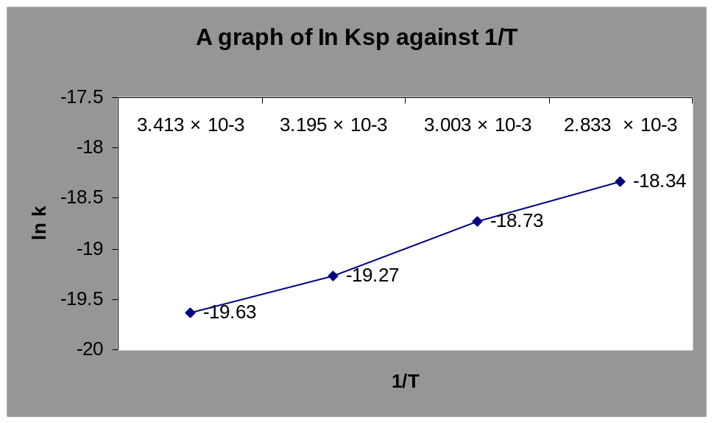

B. M (OX)_{(s)} → M²⁺_{(aq)} + OX²⁻_{(aq)} where M (OX) = metal oxalate ion

M = metal
Cation

OX² = oxalate
Ion (C₂O₄²⁻)
K = [M²⁺] [OX²⁻] But since [OX²⁻] = [M²⁺]

K = [OX²⁻] ²

From the given reaction equation:

16 H⁺ + 5 C₂O₄²⁻ _{(aq)} + 2 MnO₄⁻ _{(aq)} → 10 CO_{2 (aq)} + 2 Mn²⁺ _{(aq)} + 8 H₂0 _{(aq)}
Concentration of KMnO₄ = 1.04 × 10⁻⁴M

Volume of C₂O₄²⁻ used at various temperatures = 5.00ml

At 20ºC

Concentration = no. of moles
Volume

n (MnO₄⁻) = (1.04 × 10⁻⁴ ) × ( 1.05 × 10⁻³L)

= 1.092 × 10⁻⁷ moles

From mole ratio: n (C₂O₄²⁻) = 5
n (MnO₄⁻) 2

→ n (C₂O₄²⁻) = 5/2 × n (MnO₄⁻)

= 5/2 × 1.092 × 10⁻⁷

= 2.73 × 10⁻⁷ moles

[C₂O₄²⁻] = 2.73 × 10⁻⁷
5.00 × 10⁻³

= 5.46 × 10⁻³ M

[oxalate] = 5.46 × 10⁻³ M

K_{SP} = [oxalate] ²

= (5.46 × 10⁻³).²

= 2.98 × 10⁻⁹

In K = -19.63

From graph,

Gradient = -17.10 – ( -19.75)
(2.25 – 2.423) × 10⁻³

2.65
-0.173 × 10⁻³

= -15317.92K

= -153.18 × 10³K

But slope = -ΔHº
R
→ -153180 = -ΔH^{o )}
R

But R = 8.31 J/molK

→ ΔHº = 1272925.8 J/mol

= 127.29 KJ/mol

Substituting -ΔHº into (1) and taking points (2.65 × 10⁻³ , -18.00)

-18.00 = -127290( 2.65 × 10⁻³) + ΔSº
R R

Multiplying both sides by R = 8.31 J/molK

ΔSº = 187.74 J/mol

